1. Order Management Setup Navigation Steps. I created the Line Transaction Type First

Then, I created the Order Transaction Type for the Order Header

Then, I created the Order Transaction Type for the Order Header

Creating a Document sequence and assigning it to the Transaction Type

Assignment

1. Define and Maintain Customer Accounts and Contacts: Order Management responsibility – Purchasing – Advanced Pricing – Price Lists – Price Lists Setup

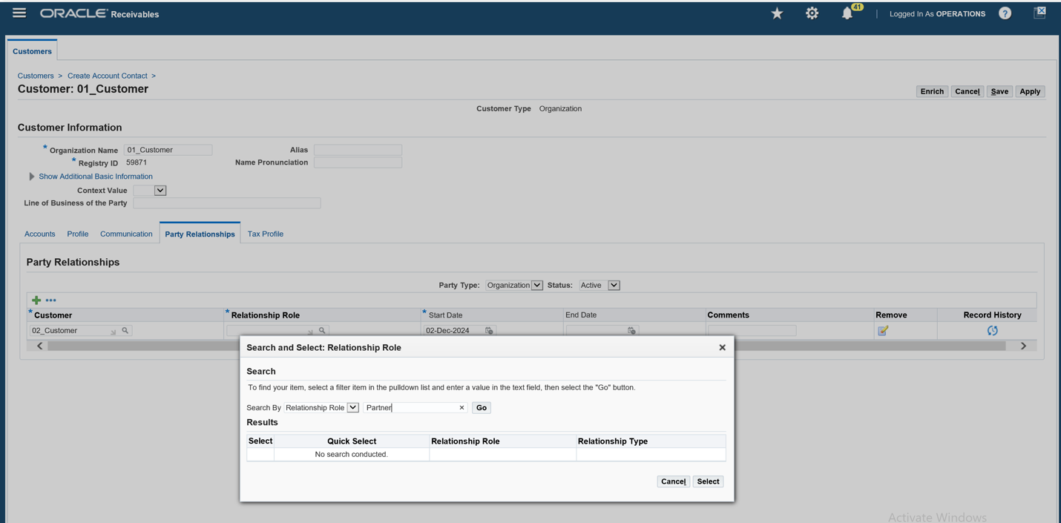

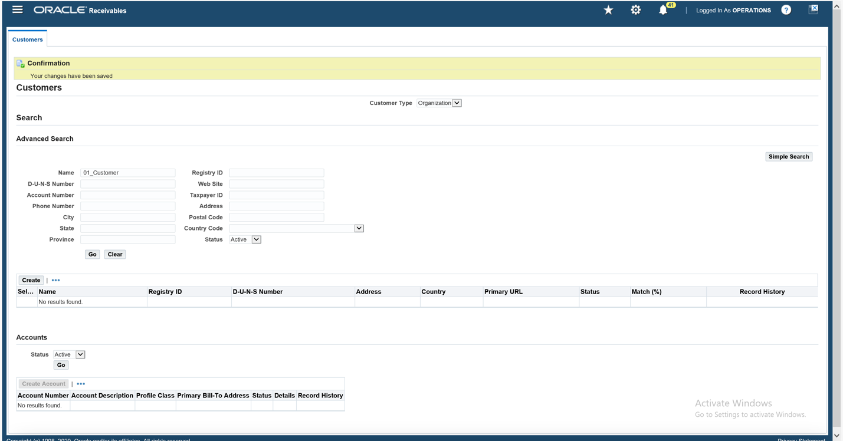

2b. Managing Customer-Specific Pricing and Discounts: Order Management responsibility – Purchasing – Advanced Pricing – Price Lists – Price Lists Setup

2b. Creating Discounts for an item. I applied a 7% discount for this item. Navigation is Order management responsibility -- Purchasing – Advanced Pricing – Modifiers – Modifier Setup

1. Order Management – Orders, Returns -- Sales Orders then book order after all required boxes have been filled in

